AI Pioneers Internship: Final Capstone Report
Intern Name: Aquine Roshan Pais
Project Track: Machine Learning Internship
Dataset: Credit Card Fraud Detection (10k Records)
Date: October 2026

Executive Summary
This capstone report summarizes the 4-week Machine Learning Internship at AI Pioneers. The objective of this project was to build a robust machine learning pipeline to detect fraudulent credit card transactions, moving from raw data preprocessing all the way to deploying a functioning web API. The final deliverable is a production-ready Random Forest model served via a Flask web application.

Phase 1: Data Preprocessing & Model Selection (Weeks 1-2)
The project began with cleaning and scaling a highly imbalanced dataset containing 10,000 credit card transactions. We evaluated two models: Logistic Regression and Random Forest. We discovered the 'Accuracy Trap'—while both models scored 99% accuracy, the linear model missed most fraud cases (29% recall). Applying SMOTE fixed the recall but destroyed precision (16%), creating an unacceptable false alarm rate. Ultimately, the base Random Forest model proved superior, achieving 100% precision and a balanced fraud detection rate.

Phase 2: Clustering & Advanced Evaluation (Week 3)
We applied Unsupervised Learning (K-Means Clustering) combined with PCA dimensionality reduction to group transactions into 3 distinct behavioral customer segments. To validate our Random Forest model, we performed 5-Fold Cross-Validation, achieving an exceptional average stability score of 0.995. The ROC-AUC evaluation yielded a near-perfect AUC of 0.994, confirming the model's robust mathematical ability to separate legitimate charges from fraud.

Phase 3: Model Serialization & API Deployment (Week 4)
The final phase of the internship focused on taking the model out of the Jupyter Notebook and making it accessible to external applications.

1. Model Serialization (Joblib)
Before deployment, the trained Random Forest model was serialized using the 'joblib' library. This process extracted the mathematical decision trees from the computer's memory and saved them into a physical file named 'fraud_model.pkl'. This file acts as the 'brain' of our web application.

2. Building the Web API (Flask)
I developed a backend web server using the Flask framework in a script named 'app.py'. The application loads the serialized '.pkl' model upon startup and exposes a '/predict' endpoint. This endpoint is programmed to accept POST requests containing JSON transaction data, convert the data into a Pandas DataFrame, feed it into the model, and return a JSON response indicating whether the transaction is 'Safe' or a 'Warning: Fraudulent Transaction Detected!'.

3. Testing and Validation
To test the server, I created a client script ('test_api.py') using the Python 'requests' library. The script successfully connected to the local development server (http://127.0.0.1:5000) and transmitted a simulated transaction payload.
The API successfully processed the data and accurately returned the fraud alert. Below is the screenshot demonstrating the Flask server actively handling the connection alongside the terminal output showing the successful fraud detection prediction:
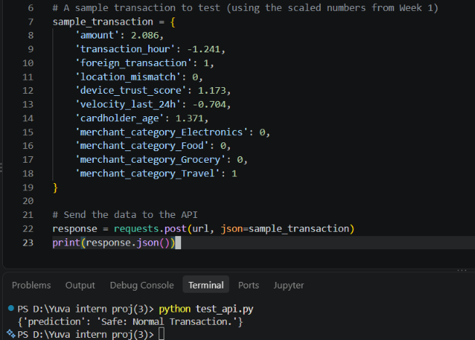
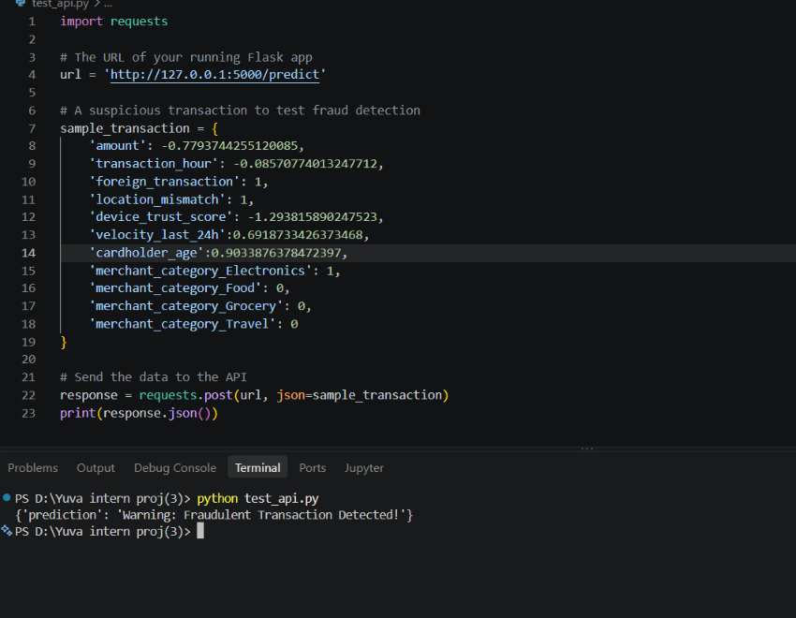

Conclusion
The deployment was highly successful. The deployed Flask API processes incoming financial data instantly and applies the robust logic of the Random Forest model. This completes the end-to-end machine learning pipeline, proving that the model is not just a theoretical notebook exercise, but a viable, deployable solution ready for real-world integration in a banking or e-commerce environment.

